# Project Name: Displaying User Feedback.

## GitHub Link:

<https://github.com/tamasjit/myjavaproject/tree/master/Phase%203/Phase-3_Practice_Project/q2_UserFeedback>

## Output:

### Landing Page:

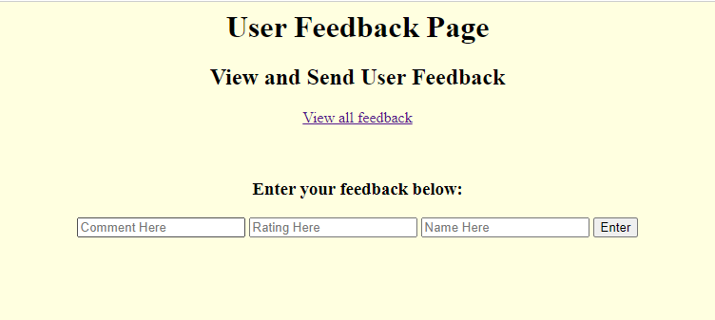

### Entering Feedback:

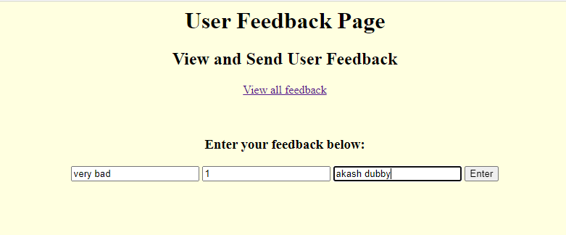

### On Successful feedback:

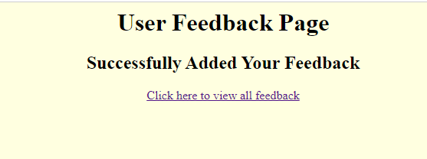

### All Feedback Given Table:

